Q1A: ANS:

select SOD.SalesOrderID, PP.Name, PPS.Name, PC.Name, SOD.UnitPrice, SOD.UnitPriceDiscount, SOD.LineTotal

from Sales.SalesOrderDetail SOD

inner join Production.Product PP

on SOD.ProductID = PP.ProductID

inner join Production.ProductSubcategory PPS

on PP.ProductSubcategoryID = PPS.ProductSubcategoryID

inner join Production.ProductCategory PC

on PC.ProductCategoryID = PPS.ProductCategoryID

order by PP.Name

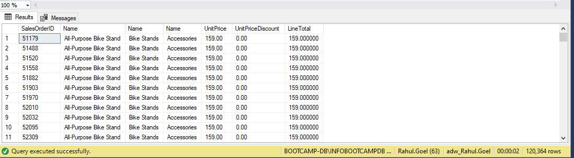

Q1B: ANS:

select P.ProductID, P.Name, PS.ProductSubcategoryID, PS.Name, PC.ProductCategoryID, PC.Name

from Production.Product P

left join Production.ProductSubcategory PS

on P.ProductSubcategoryID = PS.ProductSubcategoryID

left join Production.ProductCategory PC

on PS.ProductCategoryID = PC.ProductCategoryID

order by P.Name

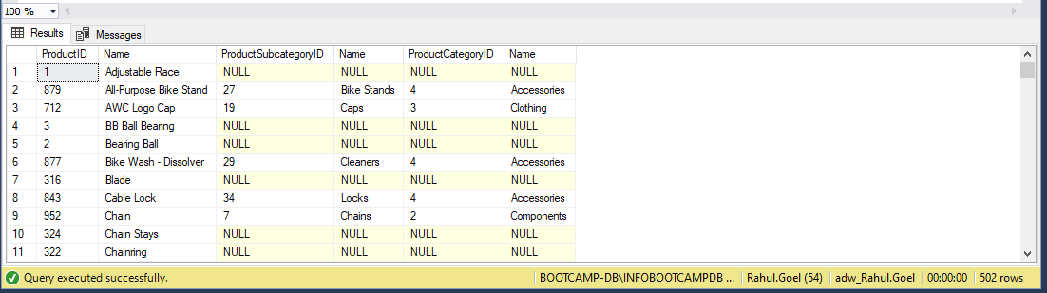

Null’s will occur in the result as we have all data from product table and only common data from category and subcategory table which does not make it mandatory that every product’s category and subcategory will be displayed.

Q2: ANS:

select PC.Name, SOH.OrderDate, sum(SOH.SubTotal)

from Sales.SalesOrderHeader SOH

inner join Sales.SalesOrderDetail SOD

on SOH.SalesOrderID = SOD.SalesOrderID

inner join Production.Product P

on SOD.ProductID = P.ProductID

inner join Production.ProductSubcategory PS

on P.ProductSubcategoryID = PS.ProductSubcategoryID

inner join Production.ProductCategory PC

on PC.ProductCategoryID = PS.ProductCategoryID

where month(SOH.OrderDate) = 12 and year(SOH.OrderDate) = 2003

group by PC.Name, SOH.OrderDate

order by 2

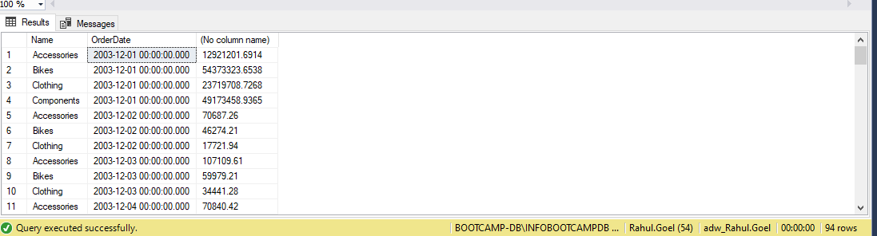

Q3: ANS:

select SOH.SalesOrderID, SR.Name, SR.ReasonType, SOH.ShipDate, SOH.SubTotal, SOH.TaxAmt, SOH.Freight, SOH.TotalDue

from Sales.SalesOrderHeader SOH

inner join Sales.SalesOrderHeaderSalesReason SOR

on SOH.SalesOrderID = SOR.SalesOrderID

inner join Sales.SalesReason SR

on SR.SalesReasonID = SOR.SalesReasonID

where SR.Name not in ('Manufacturer', 'Quality')

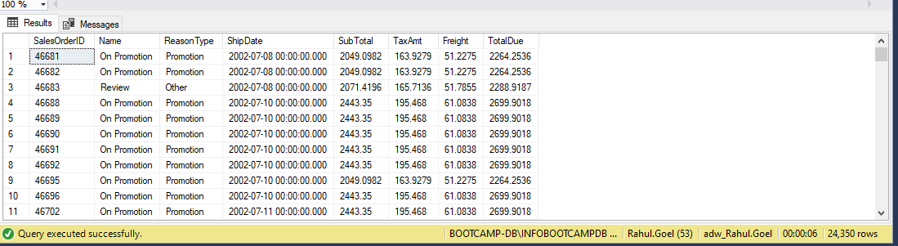

Q4: ANS:

select distinct P.Name

from Production.Product P

inner join Sales.SpecialOfferProduct SOP

on P.ProductID = SOP.ProductID

inner join Sales.SpecialOffer SO

on SOP.SpecialOfferID = SO.SpecialOfferID

where SO.DiscountPct <= 0.45 and P.Name not like 'R%'

order by 1 desc

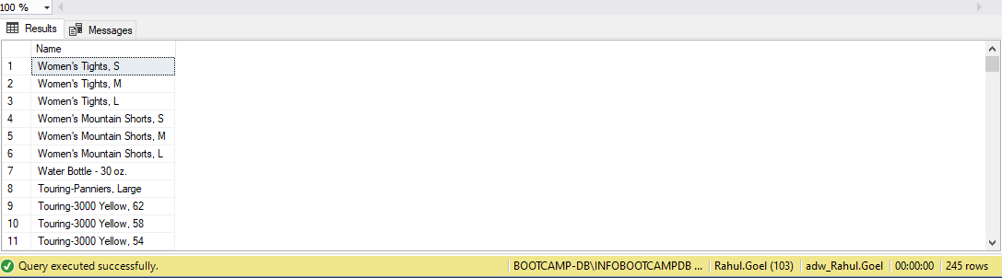

Q5: ANS:  
select Name

from Production.Product

where Name like '%[0-9]%' or Name like '%[-,/]%'

order by 1

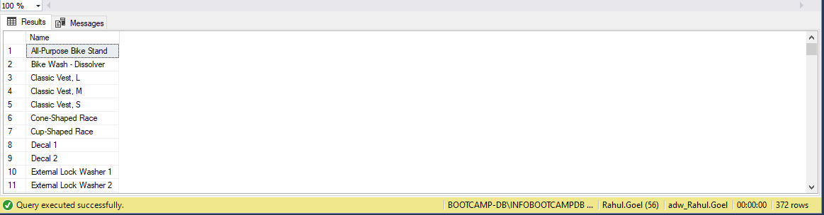

Q6: ANS:

select top 1 SP.Name, ST.TaxRate as maxtaxrate, ST.Name

from Sales.SalesTaxRate ST

inner join Person.StateProvince SP

on ST.StateProvinceID = SP.StateProvinceID

order by 2 desc

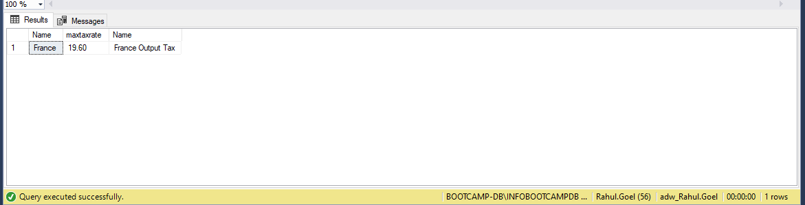

Q7: ANS:

Select St.Name, Pc.Name, Cast(Sum(Sod.Linetotal) As Numeric(10,2))  
From Sales.Salesorderheader Soh  
Inner Join Sales.Salesterritory St  
On Soh.Territoryid = St.Territoryid  
Inner Join Sales.Salesorderdetail Sod  
On Soh.Salesorderid = Sod.Salesorderid  
Inner Join Production.Product P  
On Sod.Productid = P.Productid  
Inner Join Production.Productsubcategory Ps  
On P.Productsubcategoryid = Ps.Productsubcategoryid  
Inner Join Production.Productcategory Pc  
On Ps.Productcategoryid = Pc.Productcategoryid  
Group By St.Name, Pc.Name  
Order By 1,2

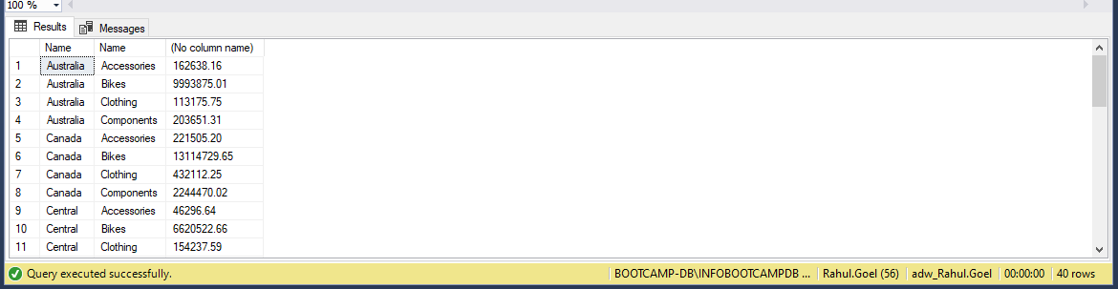

Q8: ANS:

SELECT

    CASE

        WHEN DATEDIFF(YEAR, HireDate, getdate()) < 15 THEN 'LESS than 15'

        WHEN DATEDIFF(YEAR, HireDate, getdate()) BETWEEN 15 AND 18 THEN 'BETWEEN 15 AND 18'

        WHEN DATEDIFF(YEAR, HireDate, getdate()) > 18 THEN 'Greater than 18'

    END AS Experience, SUM(SOH.SubTotal) as TotalSales ,COUNT(E.EmployeeID) AS 'Number of Employees'

FROM HumanResources.Employee E

LEFT JOIN Sales.SalesPerson SP

ON E.EmployeeID = SP.SalesPersonID

INNER JOIN Sales.SalesOrderHeader SOH

ON E.EmployeeID = SOH.SalesPersonID

where SOH.SalesPersonID = 275

Group by    CASE

        WHEN DATEDIFF(YEAR, HireDate, getdate()) < 15 THEN 'LESS than 15'

        WHEN DATEDIFF(YEAR, HireDate, getdate()) BETWEEN 15 AND 18 THEN 'BETWEEN 15 AND 18'

        WHEN DATEDIFF(YEAR, HireDate, getdate()) > 18 THEN 'Greater than 18'

END

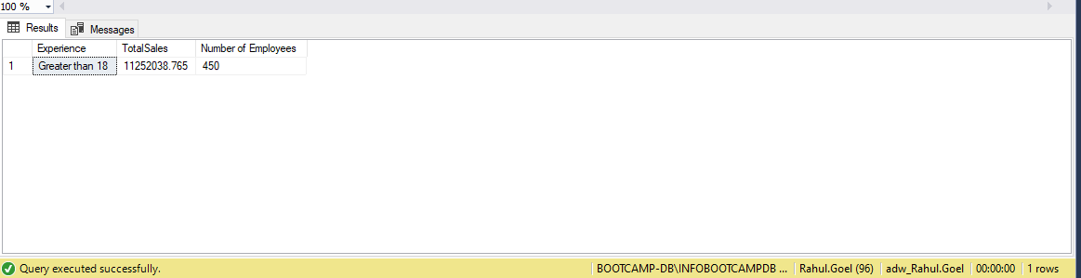

Q9: ANS:

select PC.Name, avg(SOD.OrderQty) as UnitSold

from Sales.SalesOrderHeader SOH

inner join Sales.SalesOrderDetail SOD

on SOH.SalesOrderID = SOD.SalesOrderID

inner join Production.Product P

on SOD.ProductID = P.ProductID

inner join Production.ProductSubcategory PS

on P.ProductSubcategoryID = PS.ProductSubcategoryID

inner join Production.ProductCategory PC

on PC.ProductCategoryID = PS.ProductCategoryID

where year(SOH.OrderDate) = 2003 and month(SOH.OrderDate) = 5

group by PC.Name

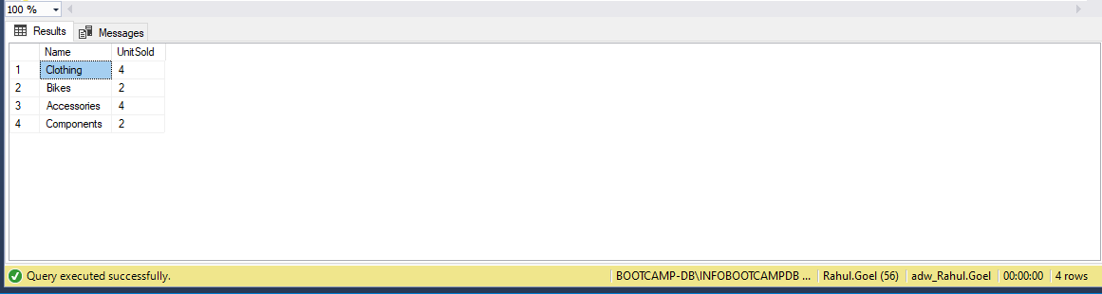

Q10A: ANS:

WITH CLOTHES AS (

    SELECT YEAR(SOH.ShipDate) AS Year, MONTH(SOH.ShipDate) AS Month, SUM(SOD.OrderQty) AS CNT_C

    FROM Sales.SalesOrderHeader SOH

    INNER JOIN Sales.SalesOrderDetail SOD

    ON SOH.SalesOrderID = SOD.SalesOrderID

    INNER JOIN Production.Product P

    ON SOD.ProductID = P.ProductID

    INNER JOIN Production.ProductSubcategory PS

    ON P.ProductSubcategoryID = PS.ProductSubcategoryID

    INNER JOIN Production.ProductCategory PC

    ON PS.ProductCategoryID = PC.ProductCategoryID

    WHERE YEAR(SOH.ShipDate) = 2003 AND PC.Name = 'Clothing'

    GROUP BY YEAR(SOH.ShipDate), MONTH(SOH.ShipDate), PC.Name

),

BIKE AS (

    SELECT YEAR(SOH.ShipDate) AS Year, MONTH(SOH.ShipDate) AS Month, SUM(SOD.OrderQty) AS CNT_B

    FROM Sales.SalesOrderHeader SOH

    INNER JOIN Sales.SalesOrderDetail SOD

    ON SOH.SalesOrderID = SOD.SalesOrderID

    INNER JOIN Production.Product P

    ON SOD.ProductID = P.ProductID

    INNER JOIN Production.ProductSubcategory PS

    ON P.ProductSubcategoryID = PS.ProductSubcategoryID

    INNER JOIN Production.ProductCategory PC

    ON PS.ProductCategoryID = PC.ProductCategoryID

    WHERE PC.Name = 'Bikes' AND YEAR(SOH.OrderDate) = 2003

    GROUP BY YEAR(SOH.ShipDate), MONTH(SOH.ShipDate), PC.Name

)

SELECT C.Year, C.Month, C.CNT_C, B.CNT_B

FROM CLOTHES C

INNER JOIN BIKE B

ON C.Month = B.Month

WHERE C.CNT_C < B.CNT_B

ORDER BY 2

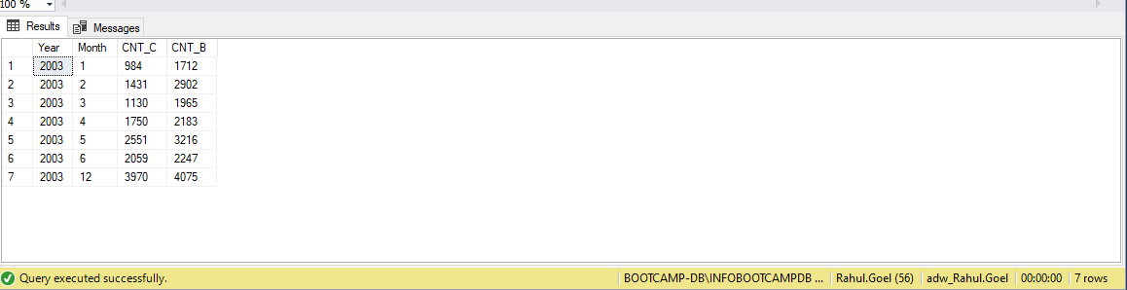

Q10B: ANS:

SELECT LEFT(P.Name,10) AS Product_Name_Broken, PD.Description

FROM Production.Product P

JOIN Production.ProductModelProductDescriptionCulture PM

ON P.ProductModelID = PM.ProductModelID

JOIN Production.ProductDescription PD

ON PM.ProductDescriptionID = PD.ProductDescriptionID

ORDER BY P.Name

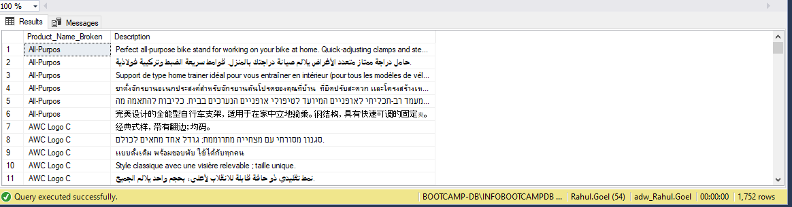

Q11: ANS:

SELECT LEFT(P.Name,10) as Broken_Product_Name,

PD.[Description],

(len(P.Name) - len(left(P.Name,10))) as No_of_characters_deleted

FROM Production.Product P

JOIN Production.ProductModelProductDescriptionCulture PM

ON P.ProductModelID = PM.ProductModelID

JOIN Production.ProductDescription PD

ON PM.ProductDescriptionID = PD.ProductDescriptionID

ORDER BY P.Name;

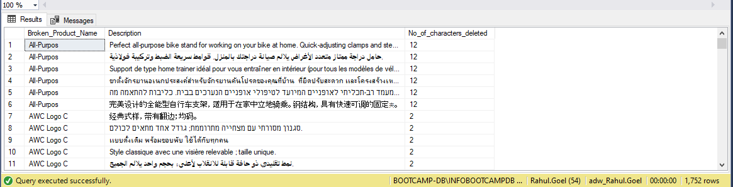

Q12: ANS:

SELECT SUM(SOD.OrderQty) AS Total_Products_Sold

FROM HumanResources.Employee E

JOIN Sales.SalesPerson SP

ON E.EmployeeID = SP.SalesPersonID

JOIN Sales.SalesOrderHeader SOH

ON SP.SalesPersonID = SOH.SalesPersonID

JOIN Sales.SalesOrderDetail SOD

ON SOH.SalesOrderID = SOD.SalesOrderID

WHERE E.MaritalStatus ='M'

AND ((DATEDIFF(MM,E.BirthDate,GETDATE())/12) BETWEEN 40 AND 50)

AND SOD.ModifiedDate BETWEEN '2003-07-01' AND '2003-09-30'

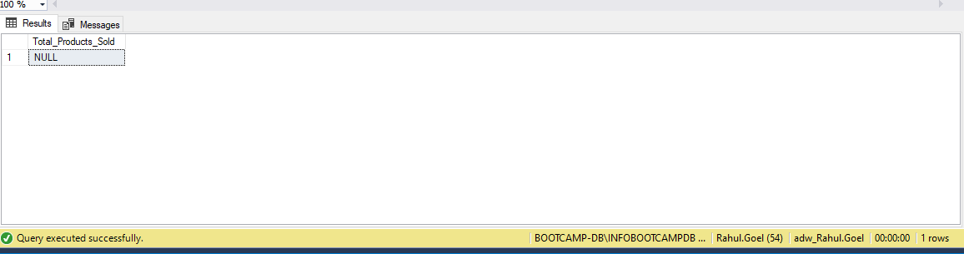

Q13: ANS:

SELECT COUNT(SC.CustomerID) AS "Count_of_Customers"

FROM (SELECT SOH.CustomerID,

COUNT(DISTINCT(PSC.ProductCategoryID)) AS [Count]

FROM Sales.Customer C

JOIN Sales.SalesOrderHeader SOH

ON C.CustomerID = SOH.CustomerID

JOIN Sales.SalesOrderDetail SOD

ON SOH.SalesOrderID = SOD.SalesOrderID

JOIN Production.Product P

ON SOD.ProductID = P.ProductID

JOIN Production.ProductSubcategory PSC

ON P.ProductSubcategoryID = PSC.ProductSubcategoryID

JOIN Production.ProductCategory PC

ON PSC.ProductCategoryID = PC.ProductCategoryID

GROUP BY SOH.CustomerID) AS SC WHERE SC.[Count]=4

GROUP BY SC.[Count]

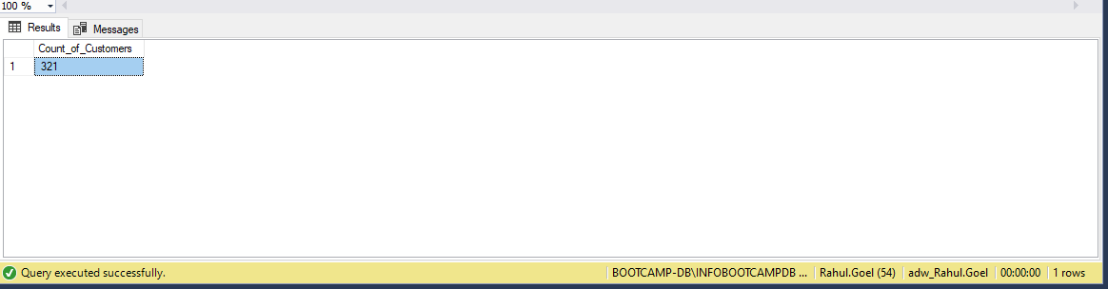

Q14: ANS:

--BIKE CTE

WITH Bike(Category, TotalSales ) -- calculates total sales of Bike

AS ( SELECT PC.Name AS "Category",

SUM(SOD.LineTotal) AS "Sales Total"

FROM Sales.SalesOrderHeader SOH

JOIN Sales.SalesOrderDetail SOD

ON SOH.SalesOrderID = SOD.SalesOrderID

JOIN Production.Product P

ON SOD.ProductID = P.ProductID

JOIN Production.ProductSubcategory PSC

ON P.ProductSubcategoryID = PSC.ProductSubcategoryID

JOIN Production.ProductCategory PC

ON PSC.ProductCategoryID = PC.ProductCategoryID

WHERE PC.Name = 'Bikes' AND SOH.OrderDate LIKE '%2004%' AND MONTH(SOH.OrderDate) ='06'

GROUP BY PC.Name ),

--ACCESSORIES CTE

Accessories(Category, TotalSales ) AS ( SELECT PC.Name AS "Category",

SUM(SOD.LineTotal) AS "TotalSales"

FROM Sales.SalesOrderHeader SOH

JOIN Sales.SalesOrderDetail SOD

ON SOH.SalesOrderID = SOD.SalesOrderID

JOIN Production.Product P

ON SOD.ProductID = P.ProductID

JOIN Production.ProductSubcategory PSC

ON P.ProductSubcategoryID = PSC.ProductSubcategoryID

JOIN Production.ProductCategory PC

ON PSC.ProductCategoryID = PC.ProductCategoryID

WHERE PC.Name = 'Accessories' AND SOH.OrderDate LIKE '%2004%' AND MONTH(SOH.OrderDate) ='06'

GROUP BY PC.Name )

--MAIN QUERY

SELECT b.Category,b.TotalSales,

CAST((b.TotalSales/SUM(SOD.LineTotal))*100 AS DECIMAL(10,2)) "Percent to Total" --total sales of bikes/total sales *100 gives percentage

FROM Bike b, Sales.SalesOrderHeader SOH

JOIN Sales.SalesOrderDetail SOD

ON SOH.SalesOrderID = SOD.SalesOrderID

WHERE SOH.OrderDate LIKE '%2004%' AND MONTH(SOH.OrderDate) ='06'

GROUP BY b.Category,b.TotalSales

UNION

SELECT a.Category,a.TotalSales,

CAST((a.TotalSales/SUM(SOD.LineTotal))*100 AS DECIMAL(10,2)) "Percent to total"

FROM Accessories a,Sales.SalesOrderHeader SOH

JOIN Sales.SalesOrderDetail SOD

ON SOH.SalesOrderID = SOD.SalesOrderID

WHERE SOH.OrderDate LIKE '%2004%' AND MONTH(SOH.OrderDate) ='06'

GROUP BY a.Category,a.TotalSales;

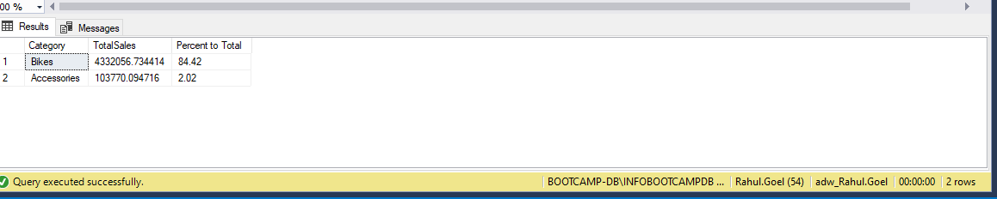

Q15: ANS:

WITH T1

AS (

SELECT SUM(SOD.LineTotal) AS "TotalSale" -- total sales grouped by each category

FROM Sales.SalesOrderDetail SOD

INNER JOIN Production.Product P

ON SOD.ProductID = P.ProductID

INNER JOIN Production.ProductSubcategory PSC

ON PSC.ProductSubcategoryID = P.ProductSubcategoryID

INNER JOIN Production.ProductCategory PC

ON PSC.ProductCategoryID = PC.ProductCategoryID

INNER JOIN Sales.SalesOrderHeader SOH

ON SOH.SalesOrderID = SOD.SalesOrderID

WHERE YEAR(SOH.OrderDate) = 2003

AND

DATENAME(MONTH,SOH.[OrderDate]) IN ('April','May' ,'June')

)

SELECT PC.Name Category,

CAST(((SUM(SOD.LineTotal)/TT.TotalSale) * 100) AS decimal(10,2)) AS Sales -- rounded to two decimal places

FROM Sales.SalesOrderDetail SOD

CROSS JOIN T1 TT

INNER JOIN Production.Product P

ON SOD.ProductID = P.ProductID

INNER JOIN Production.ProductSubcategory PSC

ON PSC.ProductSubcategoryID = P.ProductSubcategoryID

INNER JOIN Production.ProductCategory PC

ON PSC.ProductCategoryID = PC.ProductCategoryID

INNER JOIN Sales.SalesOrderHeader SOH

ON SOH.SalesOrderID = SOD.SalesOrderID

WHERE YEAR(SOH.OrderDate) = 2003

AND

DATENAME(MONTH,SOH.OrderDate) IN ('April','May', 'June')

GROUP BY PC.Name, TT.TotalSale

ORDER BY Sales DESC

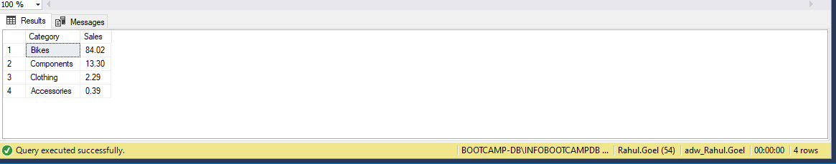

Q16: ANS:

SELECT TOP 1 *,(Maximum_Products_Sold-Minimum_Products_Sold) AS Difference_Between_Min_and_max

FROM

(SELECT PC.Name AS Product_Category,

MAX(SOD.OrderQty) AS Maximum_Products_Sold,

MIN(SOD.OrderQty) AS Minimum_Products_Sold -- stores diff between min and max

FROM Sales.SalesOrderDetail SOD

JOIN Production.Product P

ON SOD.ProductID = P.ProductID

JOIN Production.ProductSubcategory PSC

ON P.ProductSubcategoryID = PSC.ProductSubcategoryID

JOIN Production.ProductCategory PC

ON PSC.ProductCategoryID = PC.ProductCategoryID

WHERE YEAR(SOD.ModifiedDate) = 2003

group by PC.Name

) A --alias

order by Difference_Between_Min_and_max DESC

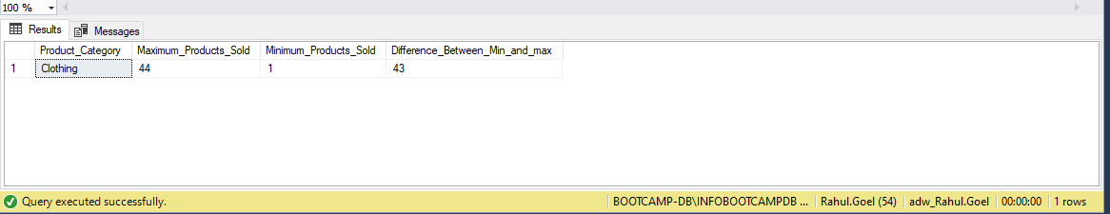

Q17: ANS:

--WITH INTERSECT

SELECT PS.Name

FROM Sales.SalesOrderHeader SOH

JOIN Sales.SalesOrderDetail SOD

ON SOH.SalesOrderID = SOD.SalesOrderID

JOIN Production.Product P

ON SOD.ProductID = P.ProductID

JOIN Production.ProductSubcategory PS

ON P.ProductSubcategoryID = PS.ProductSubcategoryID

JOIN Production.ProductCategory PC

ON PS.ProductCategoryID = PC.ProductCategoryID

WHERE (MONTH(SOH.OrderDate) = 1 AND YEAR(SOH.OrderDate) = 2003) AND PC.Name = 'Clothing' -- gives products which were sold in 2003

GROUP BY PS.Name

INTERSECT

SELECT PS.Name

FROM Sales.SalesOrderHeader SOH

JOIN Sales.SalesOrderDetail SOD

ON SOH.SalesOrderID = SOD.SalesOrderID

JOIN Production.Product P

ON SOD.ProductID = P.ProductID

JOIN Production.ProductSubcategory PS

ON P.ProductSubcategoryID = PS.ProductSubcategoryID

JOIN Production.ProductCategory PC

ON PS.ProductCategoryID = PC.ProductCategoryID

WHERE (MONTH(SOH.OrderDate) = 2 AND YEAR(SOH.OrderDate) = 2004) AND PC.Name = 'Clothing' -- gives products which were sold in 2004

GROUP BY PS.Name

ORDER BY PS.Name

--WITHOUT INTERSECT

( SELECT PS.Name

FROM Sales.SalesOrderHeader SOH

JOIN Sales.SalesOrderDetail SOD

ON SOH.SalesOrderID = SOD.SalesOrderID

JOIN Production.Product P

ON SOD.ProductID = P.ProductID

JOIN Production.ProductSubcategory PS

ON P.ProductSubcategoryID = PS.ProductSubcategoryID

JOIN Production.ProductCategory PC

ON PS.ProductCategoryID = PC.ProductCategoryID

WHERE (MONTH(SOH.OrderDate) = 1 AND YEAR(SOH.OrderDate) = 2003) AND PC.Name = 'Clothing'

GROUP BY PS.Name )

EXCEPT

( SELECT PS.Name

FROM Sales.SalesOrderHeader SOH

JOIN Sales.SalesOrderDetail SOD

ON SOH.SalesOrderID = SOD.SalesOrderID

JOIN Production.Product P

ON SOD.ProductID = P.ProductID

JOIN Production.ProductSubcategory PS

ON P.ProductSubcategoryID = PS.ProductSubcategoryID

JOIN Production.ProductCategory PC

ON PS.ProductCategoryID = PC.ProductCategoryID

WHERE (MONTH(SOH.OrderDate) = 1 AND YEAR(SOH.OrderDate) = 2003) AND PC.Name = 'Clothing'

GROUP BY PS.Name

EXCEPT

SELECT PS.Name

FROM Sales.SalesOrderHeader SOH

JOIN Sales.SalesOrderDetail SOD

ON SOH.SalesOrderID = SOD.SalesOrderID

JOIN Production.Product P

ON SOD.ProductID = P.ProductID

JOIN Production.ProductSubcategory PS

ON P.ProductSubcategoryID = PS.ProductSubcategoryID

JOIN Production.ProductCategory PC

ON PS.ProductCategoryID = PC.ProductCategoryID

WHERE (MONTH(SOH.OrderDate) = 2 AND YEAR(SOH.OrderDate) = 2004) AND PC.Name = 'Clothing'

GROUP BY PS.Name)

ORDER BY PS.Name

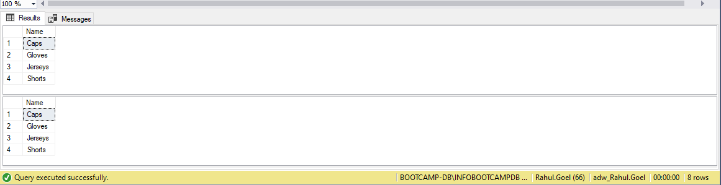

Q18: ANS:

WITH ABC AS

(

SELECT PC.Name AS "Product_Category",

P.Name "Product",

AVG(SOD.LineTotal) AS "Minimum_average_sale"

FROM Sales.SalesOrderHeader SOH

JOIN Sales.SalesOrderDetail SOD

ON SOD.SalesOrderID = SOH.SalesOrderID

JOIN Production.Product P

ON P.ProductID = SOD.ProductID

JOIN Production.ProductSubcategory PS

ON PS.ProductSubcategoryID= P.ProductSubcategoryID

JOIN Production.ProductCategory PC

ON PC.ProductCategoryID= PS.ProductCategoryID

WHERE YEAR(SOH.OrderDate) = 2003

GROUP BY PC.Name,P.Name

)

SELECT Product_Category,

Product,

Minimum_average_sale

FROM ABC a1

WHERE Minimum_average_sale = ( SELECT MIN(Minimum_average_sale)

FROM ABC

WHERE Product_Category= a1.Product_Category

)

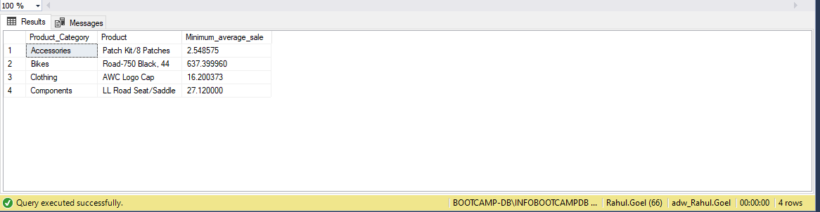

Q19A: ANS:

SELECT TOP 25 SalesOrderDetail.ProductID

INTO CustomProductID_RahulGoel

FROM Production.Product Product

JOIN Sales.SalesOrderDetail SalesOrderDetail

ON Product.ProductID = SalesOrderDetail.ProductID

GROUP BY SalesOrderDetail.ProductID

SELECT * FROM CustomProductID_RahulGoel

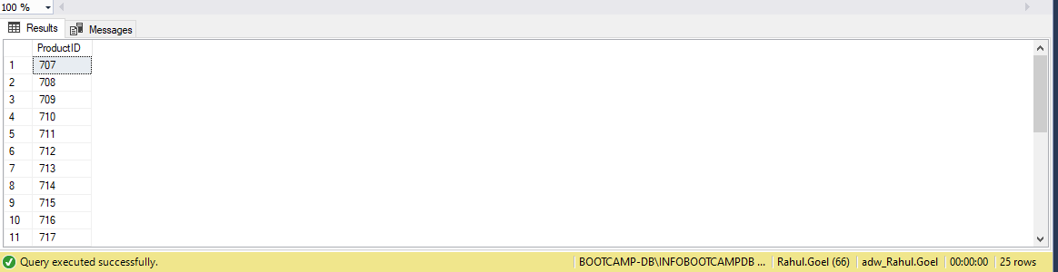

Q19B: ANS:

ALTER TABLE CustomProductID_RahulGoel

ADD ProductName VARCHAR(50)

UPDATE R

SET R.ProductName = Product.Name

FROM CustomProductID_RahulGoel R

JOIN Production.Product Product

ON Product.ProductID = R.ProductID

SELECT * FROM CustomProductID_RahulGoel

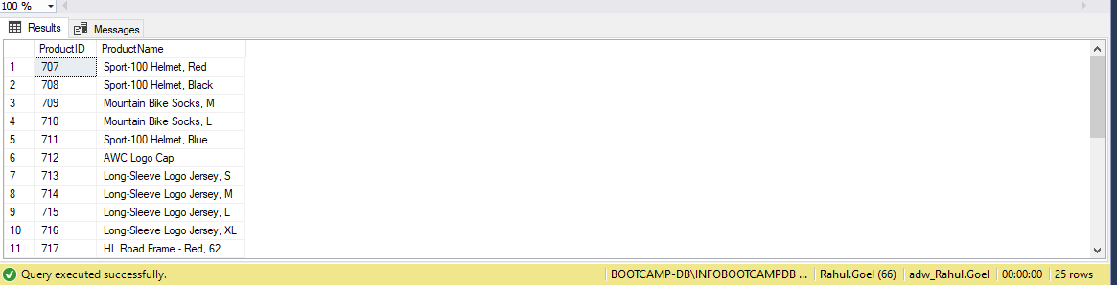

Q20: ANS:

SELECT * INTO SalesOrderDetail_RahulGoel

FROM Sales.SalesOrderDetail

WHERE OrderQty <= 10

or OrderQty >= 30

SELECT * FROM SalesOrderDetail_RahulGoel

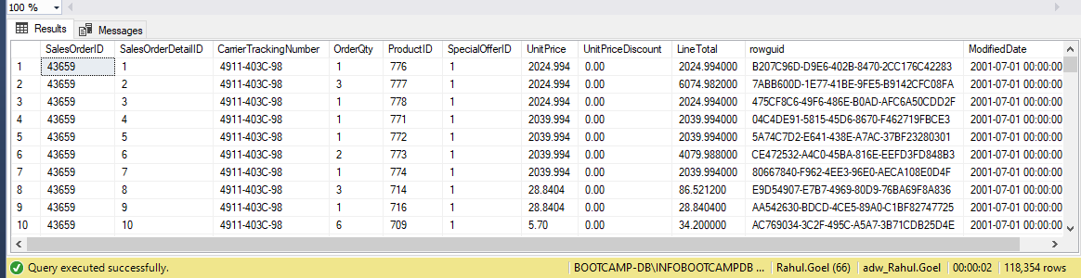

Q21: ANS:

CREATE TABLE SalesDetails_RahulGoel (CategoryID INT, SubcategoryID INT ,

Category VARCHAR (40), SubCategory VARCHAR (40), Total_Revenue2003 INT, Total_Revenue2004 INT)

WITH data_2003 (pc,psc,a,b,c)

AS

(SELECT ppc.ProductCategoryID AS pc,

ppsc.ProductSubcategoryID AS psc,

ppc.Name AS a,

ppsc.Name AS b,

SUM(LineTotal) AS c

FROM Sales.SalesOrderHeader ssoh

JOIN Sales.SalesOrderDetail sso

ON ssoh.SalesOrderID=sso.SalesOrderID

JOIN Production.Product pp

ON sso.ProductID = pp.ProductID

JOIN Production.ProductSubcategory ppsc

ON pp.ProductSubcategoryID= ppsc.ProductSubcategoryID

JOIN Production.ProductCategory ppc

ON ppsc.ProductCategoryID= ppc.ProductCategoryID

WHERE ssoh.OrderDate like '%2003%'

GROUP BY ppc.ProductCategoryID, ppsc.ProductSubcategoryID ,ppc.Name,ppsc.Name)

,

data_2004 (pc,psc,a,b,c) -- to store revenue generated in 2004

AS

(SELECT ppc.ProductCategoryID AS pc,

ppsc.ProductSubcategoryID AS psc,

ppc.Name AS a,

ppsc.Name AS b,

SUM (LineTotal) AS c

FROM Sales.SalesOrderHeader ssoh

JOIN Sales.SalesOrderDetail sso

ON ssoh.SalesOrderID=sso.SalesOrderID

JOIN Production.Product pp

ON sso.ProductID = pp.ProductID

JOIN Production.ProductSubcategory ppsc

ON pp.ProductSubcategoryID= ppsc.ProductSubcategoryID

JOIN Production.ProductCategory ppc

ON ppsc.ProductCategoryID= ppc.ProductCategoryID

WHERE ssoh.OrderDate like '%2004%'

GROUP BY ppc.ProductCategoryID, ppsc.ProductSubcategoryID ,ppc.Name,ppsc.Name)

INSERT INTO SalesDetails_RahulGoel

SELECT data_2003.pc,

data_2003.psc,

data_2003.a,

data_2003.b,

data_2003.c AS revenue1,

data_2004.c AS revenue2

FROM data_2004

FULL OUTER JOIN data_2003

ON data_2004.psc= data_2003.psc

SELECT * FROM SalesDetails_RahulGoel

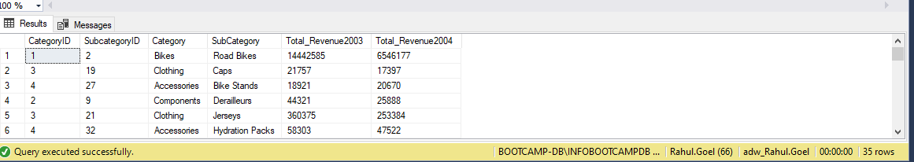

Q22A: ANS:

SELECT *

INTO Employee_RahulGoel

FROM HumanResources.Employee e

ALTER TABLE Employee_RahulGoel

ADD Salary NUMERIC (38 , 4)

UPDATE R

SET R.Salary = SalesPerson.SalesYTD

FROM Employee_RahulGoel R

JOIN HumanResources.Employee Employee

ON R.EmployeeID = Employee.EmployeeID

JOIN Sales.SalesPerson SalesPerson

ON Employee.EmployeeID = SalesPerson.SalesPersonID

SELECT * FROM Employee_RahulGoel

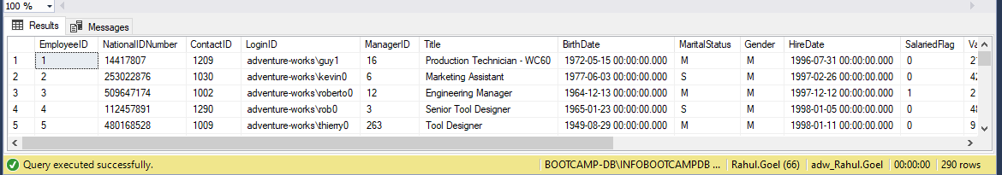

Q22B: ANS:

UPDATE r

SET Salary = (SELECT CASE

WHEN Gender = 'M' THEN Salary * 1.17

WHEN Gender = 'F' THEN Salary * 1.20

END

FROM Employee_RahulGoel rg

WHERE r.EmployeeID = rg.EmployeeID )

FROM Employee_RahulGoel r

SELECT * FROM Employee_RahulGoel

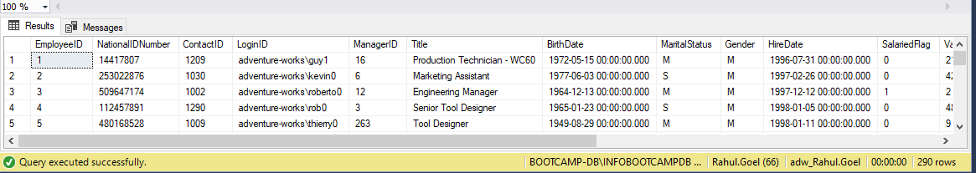

Q23: ANS:  
SELECT *

INTO CopyProduct

FROM Production.Product

Update CopyProduct

SET Name = REPLACE(

REPLACE(

REPLACE(

REPLACE(

REPLACE(

REPLACE(

REPLACE(Name, '-', ''), ',', ''), '/', ''),'@',''),'$',''),'&',''),'*','')

FROM CopyProduct

SELECT * FROM CopyProduct

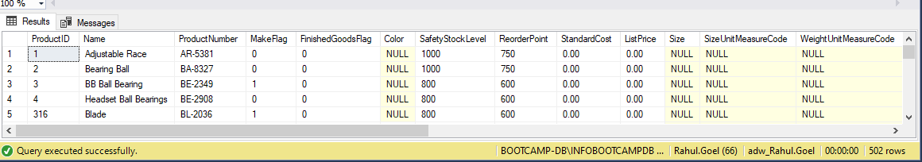

Q24: ANS:

SELECT * INTO SalesOderHeader_RahulGoel

FROM Sales.SalesOrderHeader

WITH rg AS (

SELECT ROW_NUMBER () OVER( ORDER BY SalesOrderID) AS RowNumber

FROM SalesOderHeader_RahulGoel)

DELETE FROM rg

WHERE RowNumber like '%00'

SELECT * FROM SalesOderHeader_RahulGoel

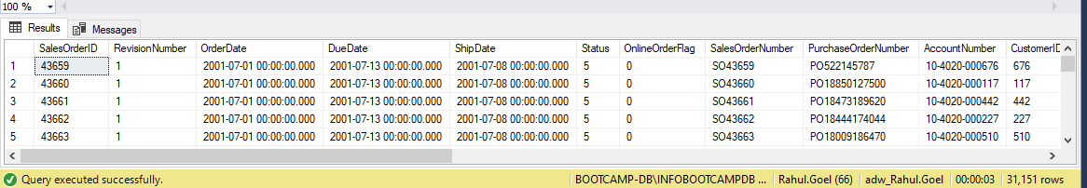

Q25: ANS:

SELECT *

INTO SalesOderDetail_RahulGoel

FROM Sales.SalesOrderDetail

WITH CTE

AS (SELECT ROW_NUMBER() OVER (

PARTITION BY ProductID

ORDER BY ProductID

) DUPLICATE

FROM SalesOderDetail_RahulGoel)

DELETE FROM CTE

WHERE DUPLICATE > 1

SELECT * FROM SalesOderDetail_RahulGoel

